 Ход белых. Выигрыш.



1. _________________ ____________________

2. _________________ ____________________

3. __________________

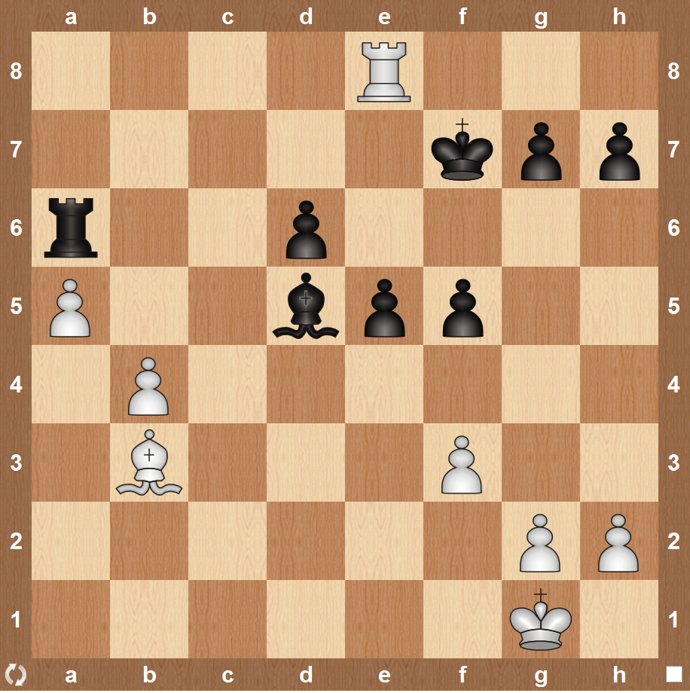



1. _________________ ____________________

2. _________________ ____________________

3. __________________

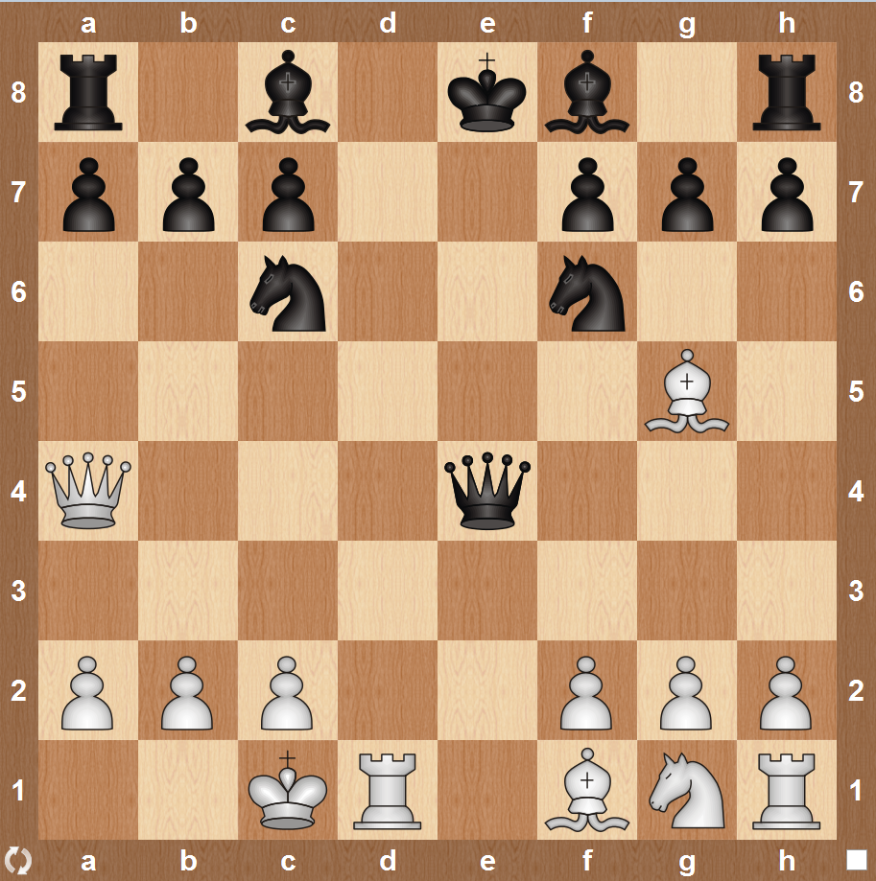



1. _________________ ____________________

2. _________________

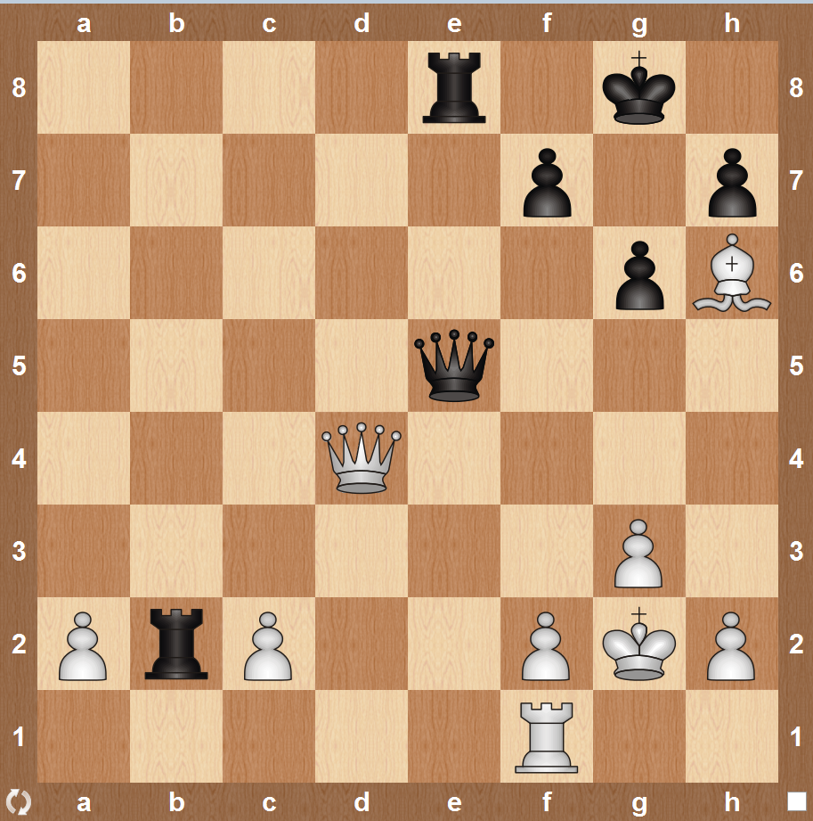



1. _________________ ____________________

2. _________________ ____________________

3. __________________

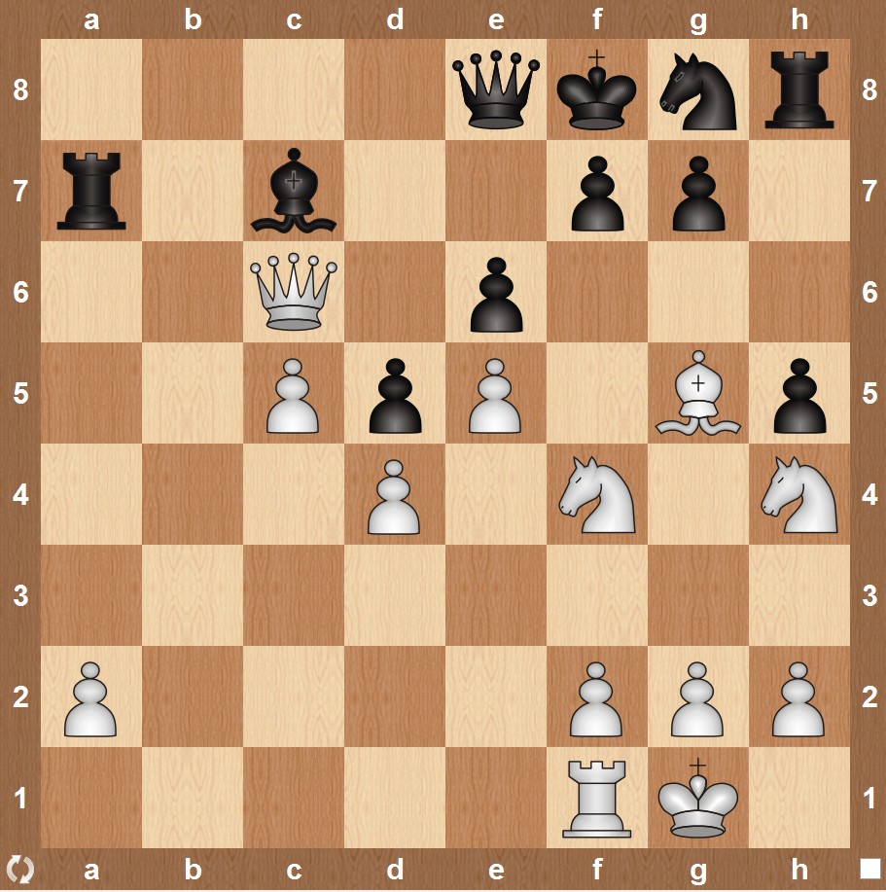



1. _________________ ____________________

2. _________________ ____________________

3. _________________ ____________________

4. _________________

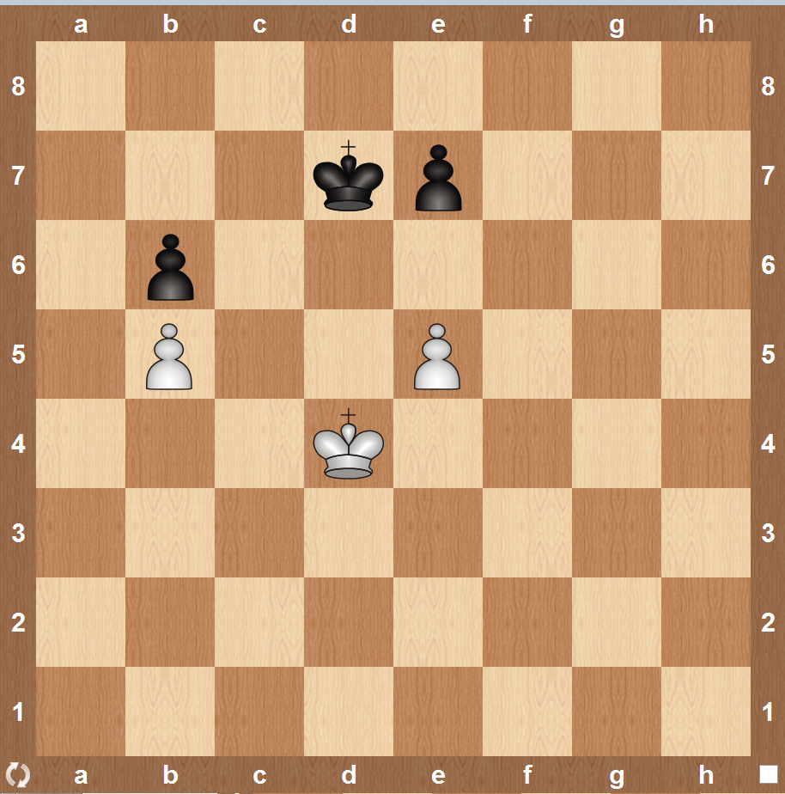



1. _________________ ____________________

2. _________________

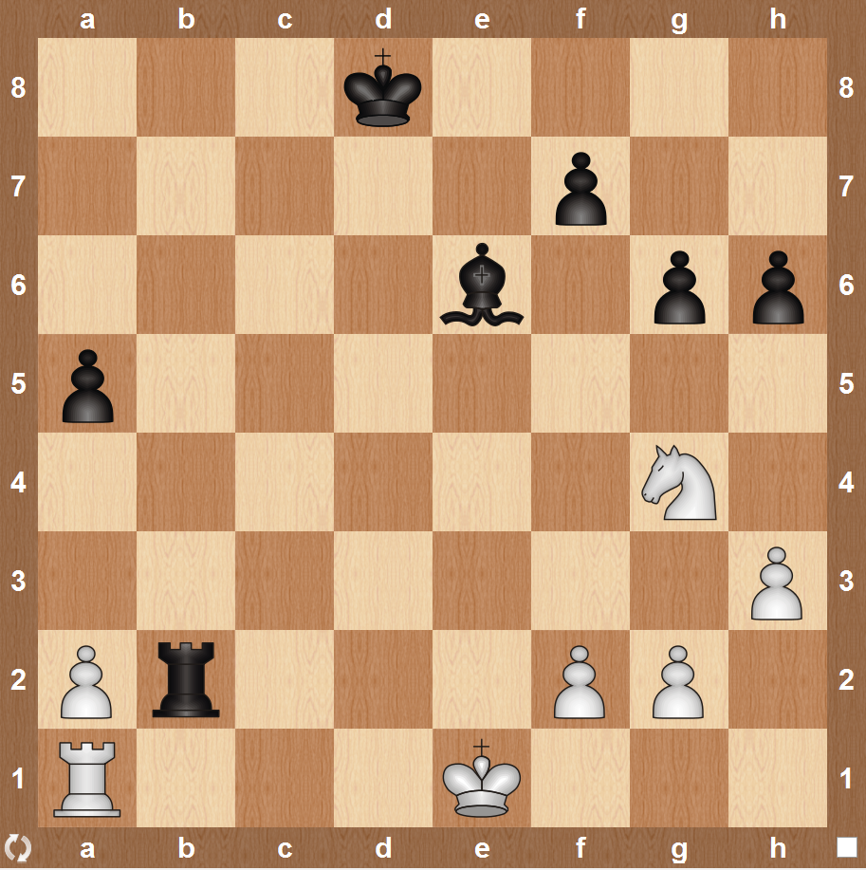



1. _________________ ____________________

2. _________________

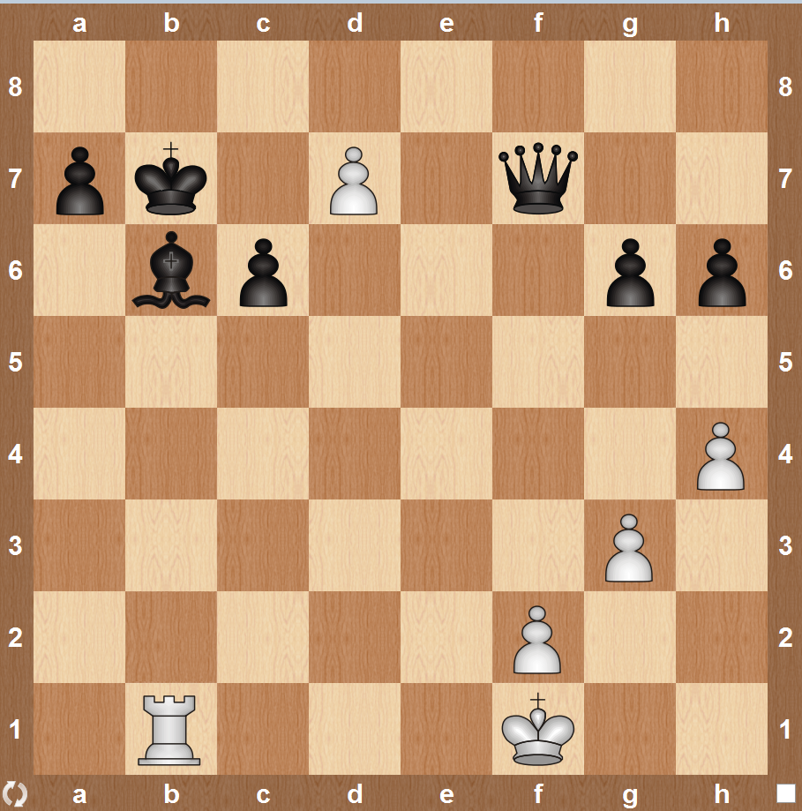



1. _________________ ____________________

2. _________________ ____________________

3. __________________

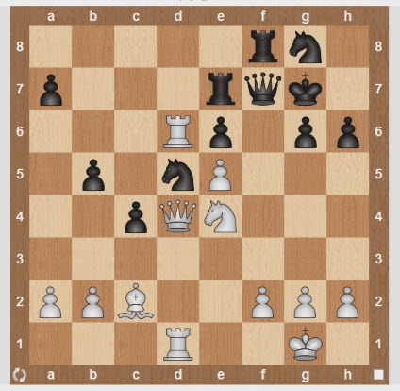



1. _________________ ____________________

2. _________________ ____________________

3. __________________

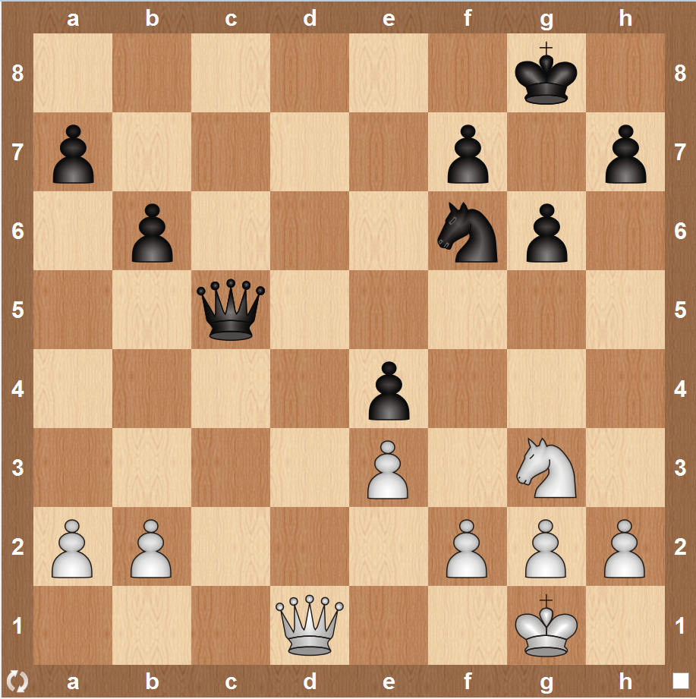



1. _________________ ____________________

2. _________________ ____________________

3. __________________

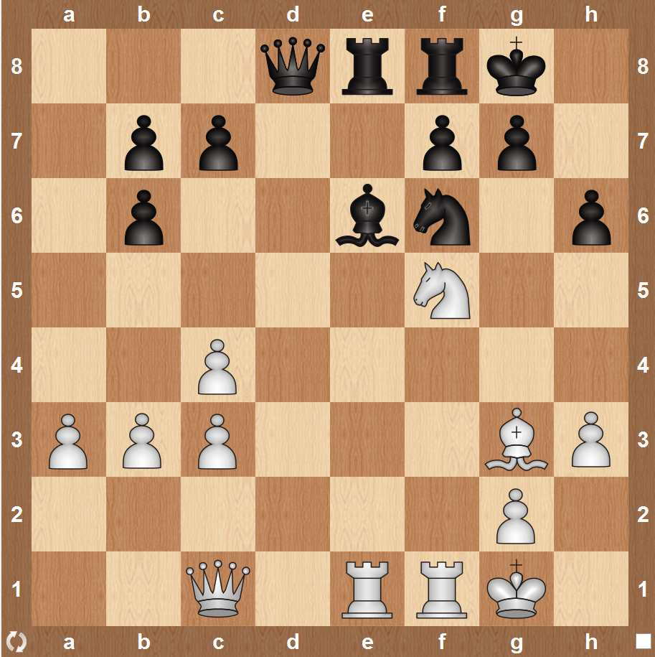



1. _________________ ____________________

2. _________________ ____________________

3. __________________

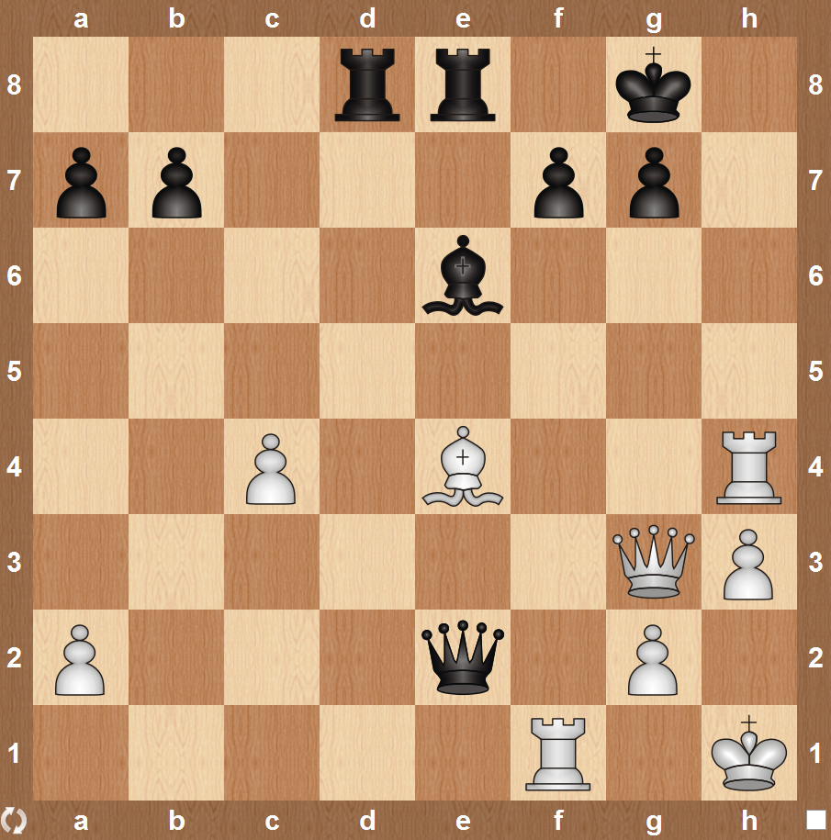



1. _________________ ____________________

2. _________________ ____________________

3. __________________

